
Report

Date | 21 September 2026
Team ID | MCA
Project Name | Strategic Employee Attrition Intelligence Board
Maximum Marks | 5 Marks

A report is a comprehensive document that provides a detailed and structured account of data analysis, findings, and insights. It is typically used for in-depth analysis, documentation, and communication of results. Reports are suitable for a diverse audience, including decision-makers, analysts, and stakeholders who need a comprehensive understanding of the data.
Designing a report in Power BI involves connecting to data sources, creating visualizations like charts and graphs, customizing their appearance and interactivity, organizing them logically on the canvas, formatting elements for consistency and clarity, and optionally creating dashboards for a summarized view. Throughout the process, it's essential to consider the audience's needs and ensure the report effectively communicates insights from the data. Finally, iterate based on feedback to continually improve the report's design and usefulness.
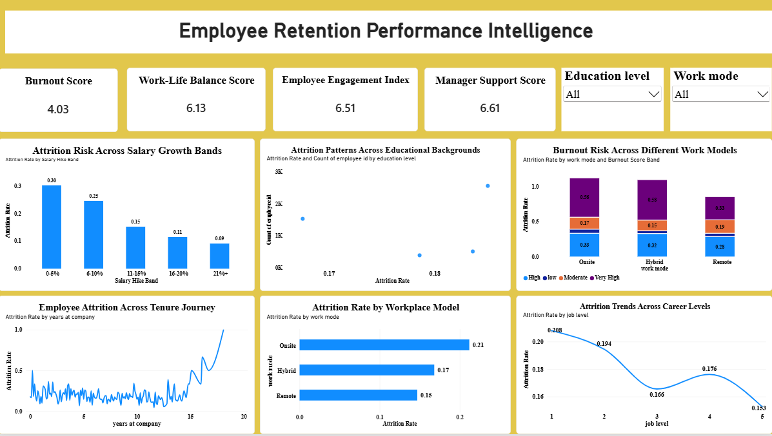
Observations Drawn from the Power BI Report
Observations from the Strategic Employee Attrition Intelligence Dashboard provide valuable insights into employee turnover patterns and the factors associated with attrition.
1. Attrition Overview
● Analyze key KPIs such as total employees, attrition count, and attrition rate to understand the overall employee turnover in the organization.
2. Attrition Rate Comparisons
● Compare attrition rates across departments and job roles to identify areas with differences in employee turnover.
3. Work Mode Analysis
● Examine employee attrition across different work modes to understand how work arrangements are associated with employee turnover.
4. AI Tool Usage and Attrition
● Analyze AI tool usage in relation to employee attrition to identify patterns between technology adoption and employee turnover.
5. Employee Wellbeing and Attrition
● Compare burnout, engagement, and work-life balance across employees based on their attrition.

Example:
- Attrition Risk Across Salary Growth Bands
This bar chart shows that higher salary hikes correlate directly with lower turnover. Employees receiving a 0–5% hike experience the highest attrition rate at 0.30, while those with a 21%+ hike have the lowest risk at 0.09.
- Attrition Patterns Across Educational Backgrounds
This scatter plot maps employee counts against attrition rates based on their educational levels. It helps HR leaders quickly identify which academic cohorts represent the highest volume of staff and how their specific departure rates compare.
- Burnout Risk Across Different Work Models
This stacked bar chart evaluates how workload fatigue impacts retention across Onsite, Hybrid, and Remote setups. It reveals that Onsite workers experience the highest proportion of "Very High" burnout risk, closely followed by Hybrid employees.
- Employee Attrition Across Tenure Journey
This line graph tracks employee departures relative to their total years at the company. It displays a volatile but relatively stable pattern during the first 15 years, followed by a sharp, dramatic increase in attrition as employees approach their 20-year milestone.
- Attrition Rate by Workplace Model
This horizontal bar chart compares overall turnover rates by operational environment. Onsite working models lead the company in turnover with a 0.21 attrition rate, while remote arrangements prove the most stable at 0.15.
- Attrition Trends Across Career Levels
This line graph illustrates employee turnover across five distinct job seniority tiers. Attrition peaks early at Level 1 with a rate of 0.208, steadily drops to a low of 0.166 at Level 3, and reaches its absolute lowest point at Level 5 (0.153).
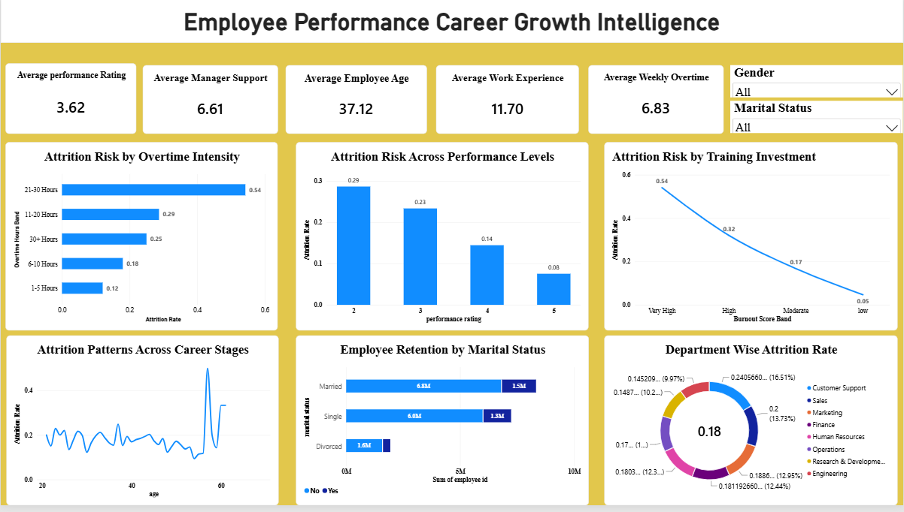

- Attrition Risk by Overtime Intensity
This horizontal bar chart highlights a strong link between heavy overtime hours and staff departures. Employees working 21–30 hours of overtime have a massive 0.54 attrition rate, while those keeping overtime under 5 hours are the most stable at 0.12.
- Attrition Risk Across Performance Levels
This vertical bar chart tracks turnover against individual performance ratings ranging from 2 to 5. It shows that lower performers leave at the highest rate (0.29), while top-tier performers with a rating of 5 are highly retained with an attrition rate of just 0.08.
- Attrition Risk by Training Investment
Despite the title's reference to training, this line graph actually measures attrition across different burnout score bands. It shows a linear trend where attrition plummets from a peak of 0.54 for employees experiencing "Very High" burnout down to a mere 0.05 for those with "Low" burnout.
- Attrition Patterns Across Career Stages
This line chart tracks how employee turnover fluctuates by age from 20 to over 60 years old. Attrition rates remain relatively volatile but steady through middle age, followed by a dramatic spike and subsequent drop as employees near retirement age around 60.
- Employee Retention by Marital Status
This stacked horizontal bar chart visualizes retention counts ("No" vs. "Yes" to attrition) grouped by marital status. It shows that the Married cohort represents the largest volume of employees, while the Divorced group is the smallest segment in the dataset.
- Department Wise Attrition Rate
This donut chart displays the breakdown of the company's overall 0.18 attrition rate across different business units. The highest share of departures comes from Sales (16.51%), closely followed by Customer Support, while smaller segments make up the remaining percentage slices.

